**Reference No:** C36…..

**Damage Report Date:** .20/05/14...

**Incidents must be reported immediately.**

Damage found in Container must not to be touched until pictures have been taken to effectively demonstrate to stake holders how damage could have occurred?

In Container Container No.

In Warehouse How was it damaged? Slip sheet Forklift in driving Rack

Product

RXV377B S/N (21)T1420742P

*Insert* Picture:

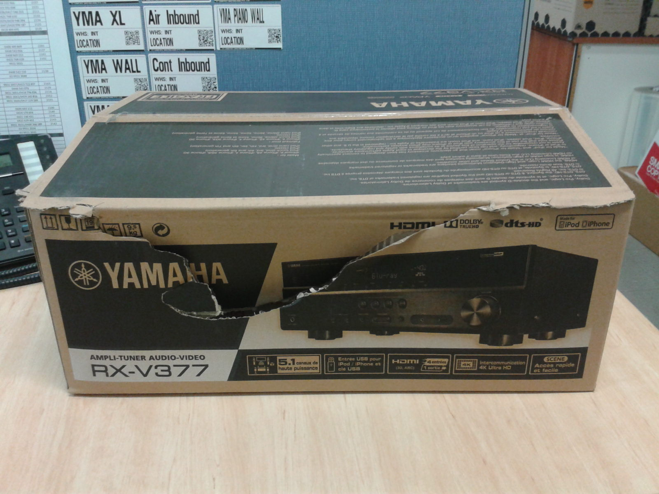

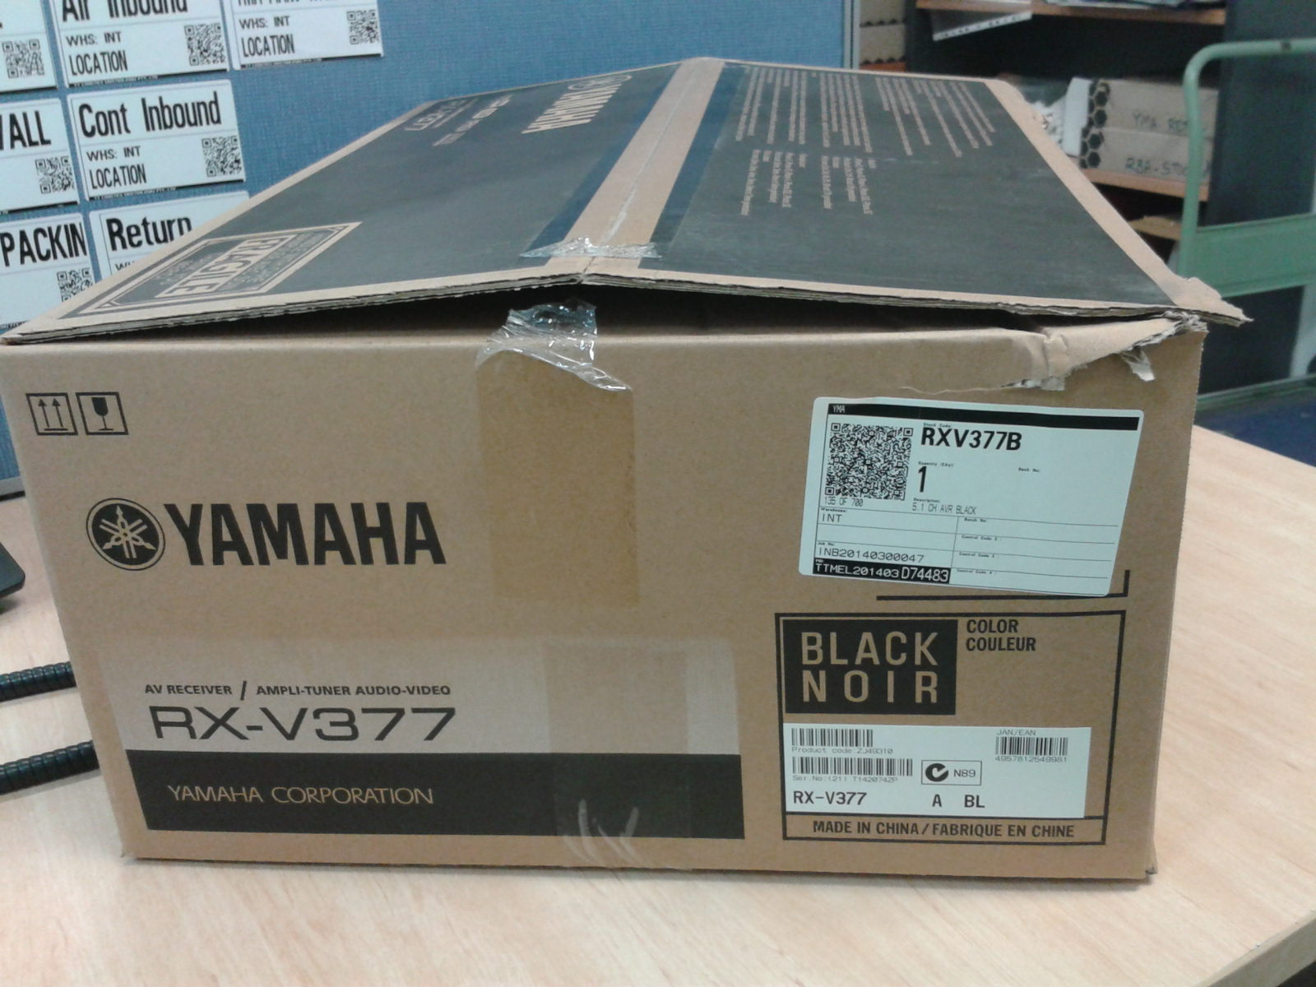

Reported by…Brian…………………………………….